Crawford https://crawford-engineering.vercel.app/
Word to do
smooth, 60fps, animations smooth.
Projects pics , slides chalani ha , slide show
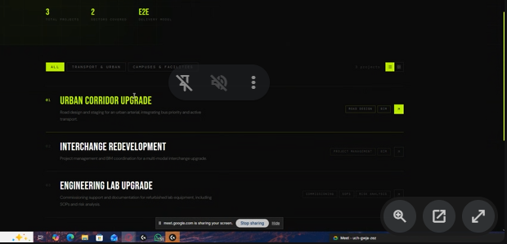

List achi ha sath me slider
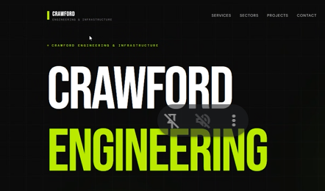
Ye jo oper ha use remove kar do

Auto type me add karna
Project management
Cost estimation

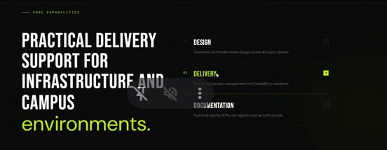
Data provide ho ga, links connect karni ha sari
Jaha page banta ha wo bana ka bs chipka de ge pics
Our Services
Road and railway ikhata

--
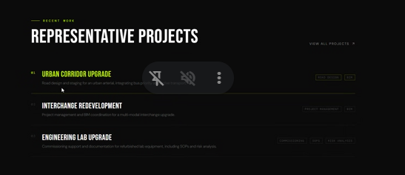
Pics daale ge yaha pe

New page
Our team
CEO waqar, umair
Addresses
Autrailia
Qatar , dubai

Single Service Page
Service kholo , waha us ki images and desciprtion

Hosting ho jaye gi
Changes easily update ho jae gi msla nai ha

Animation:
Dalni ha

